Posted 03/07/2011 at 11:40 am by JAV

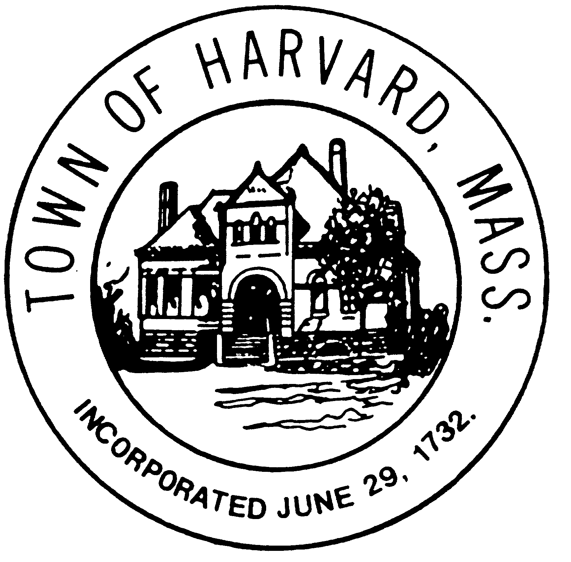

Board: Municipal Buildings Committee
Day & Date: Thursday, March 10, 2011
Time: 9:30 am– 11:00 am
Location: Town Hall

Agenda:

- Reading and approval of minutes of various previous meetings
- Preparation for LWV’s forum
- Review schedule, materials and venues for ‘out-reach’ effort.
- Review of meetings with Boards and Committees

